Background

1) Autonomous Systems

When we hear the phrase "Autonomous System", we think of industry automation, UAVs (Unmanned Aerial Vehicles), self-driving cars and the list goes on. These are all modern technologies with ancient roots. The idea of autonomous systems can be dated back to centuries ago with the "airscrew", conceptualized by Leonardo Da Vinci in the 15th century [FOL76], which is now more commonly known as Da Vinci’s Helicopter. The modern history of automation goes back to the World War II, when Alan Turing developed the Bombe, which helped decipher the German cipher machine, Enigma. He went on to invent the Turing Machine which he called the "a-machine" or "automatic machine" [Hod12]. The Turing Machine is the conceptual precursor of the modern computer, and helps explain the theory of automation. Every modern technology uses the theory of automation in some form. A simple if-else statement in a basic computer programming language is an example of automation. Modern applications of autonomous systems deal with solving modern problems, like an efficient transportation without human interference, e.g., self-driving cars, [Urm08], home automation with cleaning robots like Roomba by iRobot [FD06], factory automation in terms of precise manufacturing, warehouse organization [Kon00], and delivery using robots [Zho14].

1. Self Driving Cars: Self-driving cars (or autonomous cars, or driverless cars) is currently a hot research topic in the automotive industry as well as in academia. Many companies have put in thousands of hours of research into bringing the best technology in the market. Recently, the technology has also been nearly successfully commercialized by companies like Tesla, Uber, Aptiv, NuTonomy, etc. The beginning of the research can be dated back even before the DARPA Grand Challenge in 2004 where all the competing cars failed during the initial miles, but realized a platform to showcase their research in autonomous cars. The challenge was repeated in 2005 [Bue07] where the car Stanley by Stanford University bagged the first position [Thr06].

2. Warehouse and Delivery Robots: A solution, provided by the engineers to the supply-chain management and logistics problem, are the warehouse and delivery robots. [ROB16] states the need of robotics in logistics. These robots are capable of navigating the warehouse by either learning the map or using a predefined map of the warehouse. Unlike self driving cars, GPS is not an option available since there is no GPS signal available indoors. The localization problem is solved by using beacons or visual/colored landmarks which the robots use to estimate their position. The robots can pick, drop, and sort packages within the warehouse. Since the map of the ware house is usually static with defined locations of shelves and stacks for picking and dropping, path planning is as easy as implementing one algorithm and updating the path dynamically to avoid any moving obstacles in the way.

2) Common pipeline

Every autonomous robot developed follows a common control pipeline. The control is a closed loop system with feedback, so the autonomous robot needs sensors. Fig. 2.1 shows a common control pipeline which is at the core of every autonomous robot. Two types of sensors are commonly used:

• Exteroceptive Sensors: Those which help in sensing the environment, i.e., external to the robot. Example: LiDAR, Camera, Ultrasonic Sensor, Radar.

• Proprioceptive Sensors: Those which help in sensing/measuring the state of the "ego robot," i.e., the robot itself. Example: Encoders, IMU.
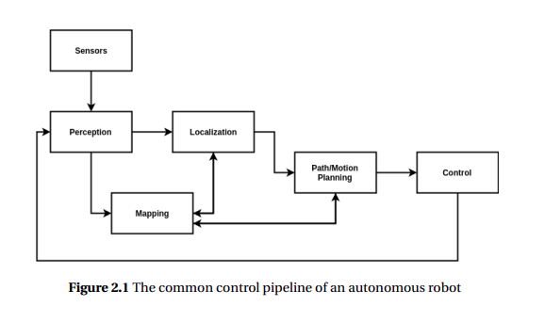
Perception, in simple words, is what the sensors see (perceive) from the environment. Sensors can see a person walking (dynamic object) or a painting on the wall (static object or Landmark). These observations are used to build a map of the environment. The static objects (or landmarks) are a part of the global map, where as dynamic objects are used by the local planner to plan a path around them by estimating the motion of the dynamic objects.

Another part of the pipeline is Localization. The landmarks generated by the perception algorithm are used to learn a map. These landmarks are also used to estimate the pose (position and orientation) of the robot in the generated map. Unlike self-driving cars, where a major source of positional data is the GPS receiver, indoor robots used for warehouse navigation and vacuum cleaning robots cannot rely on the GPS for navigation and localization. Various algorithms have been proposed for localization that do not require GPS. These algorithms use sensors like LiDAR and camera to make sense of the environment and estimate the pose of the robot. [LT10] proposed a localization method that makes use of an offline grid map of probability distributions over environment reflectance to the laser rays from the LiDAR. Some methods use LiDAR data to build a map and camera data to estimate the location of the self-driving car relative to the generated map. [Xu17] proposed a localization method that matches stereo images to a 3D point-cloud map.

Once the map is generated and the robot is localized, the next step is the decision making which includes planning a path to the destination and also taking care of the Holonomic constraints of the robot while doing so. Algorithms like Dijkstra’s, A*, RRT, and RRT* are used for path planning.

The localization problem and the Mapping problem together construct the SLAM problem. The attempt is to squeeze the localization and mapping pipeline into one single SLAM algorithm. SLAM or Simultaneous Localization and Mapping has been the most talked of problem in the field of Robotics. The problem was first introduced by DurrantWhyte and John J. Leanord in 1991 [LDW91]. The problem states that if a moving robot is kept in an unknown environment, how likely is it to build a consistent map of the observed environment while estimating the current location and navigating through the environment. Over the past two decades, many solutions to the SLAM problem have been provided and is now considered to be solved. Some solutions require a combination of sensors whereas some require only one sensor. Algorithms are designed to process the incoming data from these sensors and build a map through observing environment, learning landmarks, and simultaneously estimating the location of the moving platform in that map with respect to the landmarks.

Any uncertainty inherent in either mapping and/or localization is commonly caused by noisy sensor measurements. Uncertainty leads to the inaccurate perception of an environment. Separately, Localization and Mapping can be explained by the following equations:

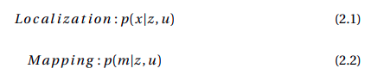

Where, m is the environment map, x is the current pose of the robot in the world frame, z is the observation, i.e., information from sensor measurements, and u is the control command given to the robot, or odometry from the robot. Together these form the SLAM problem as follows.

Given,
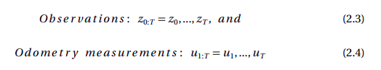

Find,

Where, the SLAM problem is solved over time (0:T) and is expressed as a conditional probability of the path (x0:T : pose over time) and map (m), given observations (z0:T ) and control and odometry (u1:T ) over time. This probability usually follows a Gaussian distribution which helps with better estimation of the unknown states over time.

Many LiDAR based SLAM algorithms use Kalman Filters or Particle Filters [Gri05] and [Gri07] (aka Sequential Monte Carlo) based on Monte Carlo algorithms, whereas Visual (camera based) SLAM incorporates Structure from Motion (SFM) techniques to estimate the camera pose and motion in the environment by processing multiple images of the same environment taken from different angles.

